Auto Audio

Sprint 1 Plan

The Awesome Team

Sprint Completion Date: July 9, 2019

Revision 1, July 2, 2019

Goals:

1. Convert recorded sound to readable data
   1. Read in sound data
   2. Convert to digital data
2. Convert said data into notes, written in the format <note><octave><sharp/flat/natural>

Tasks:

* As someone who is new to piano, I want an app that can tell me the note that corresponds to the key I am pressing so that I can learn which key is which.
  + Record audio and determine its frequency. Utilizing either a software command, or hardware parts.
    - Time Estimate: 2 days
  + Determine which note (on piano) is closest to given frequency.
    - Time Estimate: 2 hrs
* As a deaf and aspiring singer, I want to be able to classify frequencies to make the learning process much more efficient
  + Print out/display notes
    - Time estimate: 2 hrs

Team Roles:

* Erica: Product Owner, Developer
* Jeffrey: Developer
* Weixiang: Developer
* Max: Scrum Master, Developer
* Michael: Developer

Initial Task Assignment:

* Erica: Determine which note (on piano) is closest to given frequency (Algorithm)
* Jeffrey: Determine which note (on piano) is closest to given frequency (Algorithm)
* Weixiang: Record audio and determine its frequency. Utilizing hardware parts.
* Max: Record audio and determine its frequency. Utilizing software commands.
* Michael: Record audio and determine its frequency. Utilizing software commands.

Initial Burnup Chart:

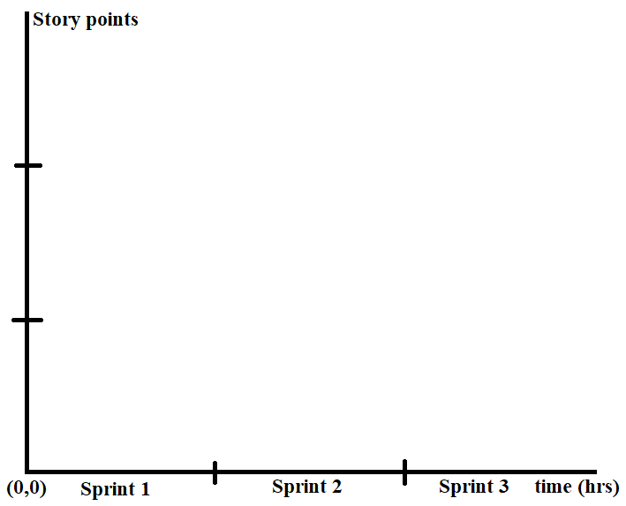

Initial Scrum Board:

|  |  |  |  |
| --- | --- | --- | --- |
| Stories: | To Do: | In Progress | Done: |
| As someone who is new to piano, I want an app that can tell me the note that corresponds to the key I am pressing so that I can learn which key is which. | 1. Record audio and determine its frequency. Utilizing either a software command, or hardware parts. 2. Hardcoding which frequencies are what notes. | Null | Null |
| As a deaf and aspiring singer, I want to be able to classify frequencies to make the learning process much more efficient | * Determine which note (on piano) is closest to given frequency (Algorithm) | Null | Null |

Scrum times: Tuesday 1PM, Thursday 1PM (with TA), Friday 3PM